

Bahria University, Islamabad

Department of Software Engineering

Artificial Intelligence Lab (Spring-2026)
Instructor: Engr. Saad Mazhar

Student: Muhammad Hamza
Enrollment: 01-131232-057

Lab Journal: 12
Date: 23-04-2026

Task No: | Task Wise Marks |  | Documentation Marks |  |  | Total Marks  (20)
 | Assigned | Obtained | Assigned | Obtained
1
2
3
4
5
Comments:

Signature

LAB # 12
Implementing Tkinter (GUI Basic)
Github Link:
https://github.com/muhammadhamza7057/Machine-Learning-Mastery/tree/main/Lab-12
Objective:
- To understand the basics of GUI development using Python Tkinter.
- To design and implement a user-friendly Employee Registration Form using labels, entry fields, and buttons.
- To apply input validation techniques to ensure correct and secure user data entry.
- To develop a simple Salary Utility Calculator for computing total salary based on user input.

Code:

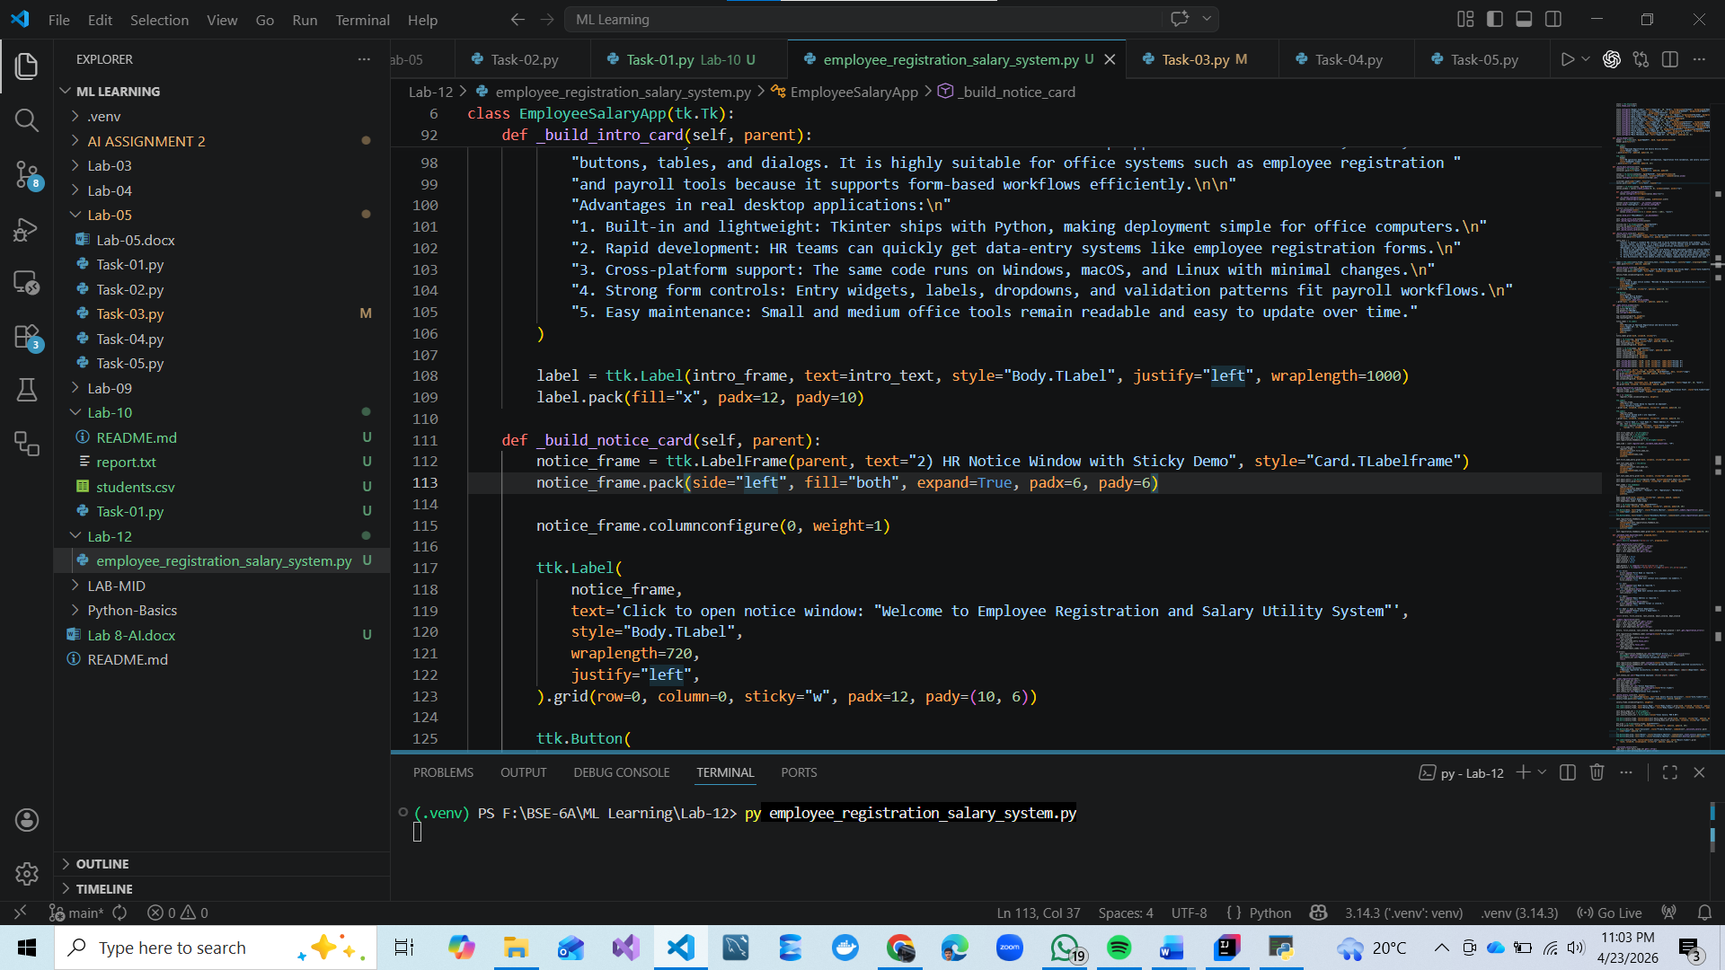

Screenshots:

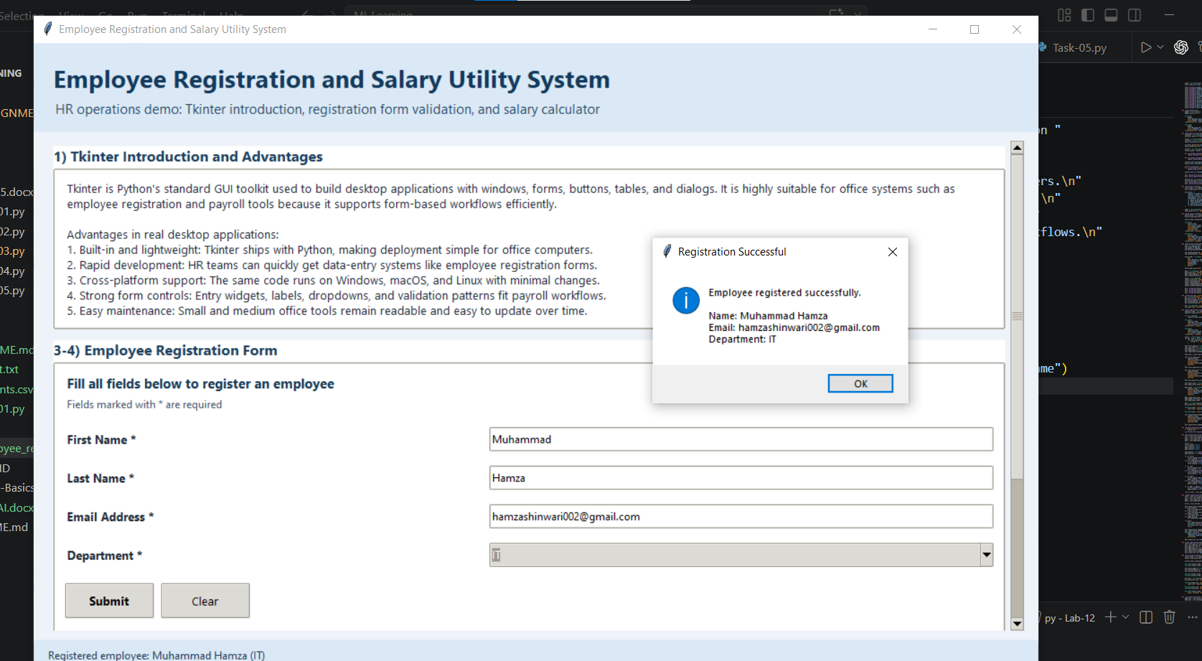
Entering the Registration form data.

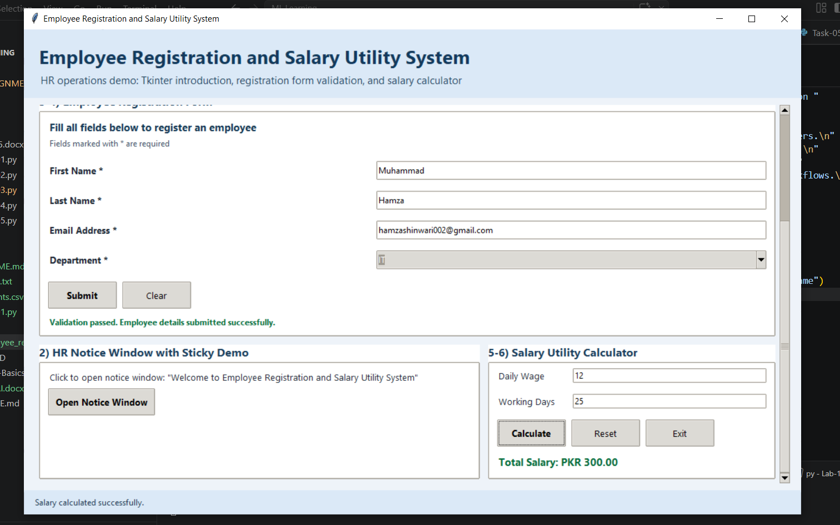
Entering the Utility data.

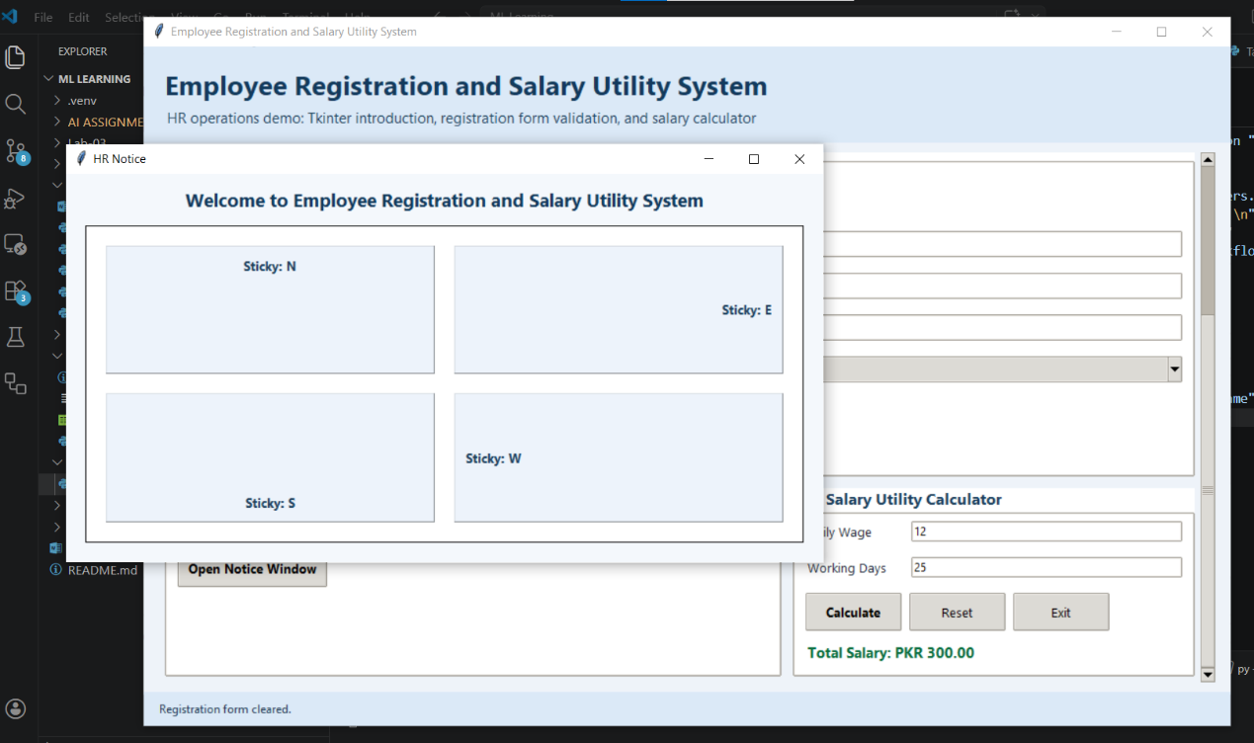
Opening the Open Notice Window for the HR.

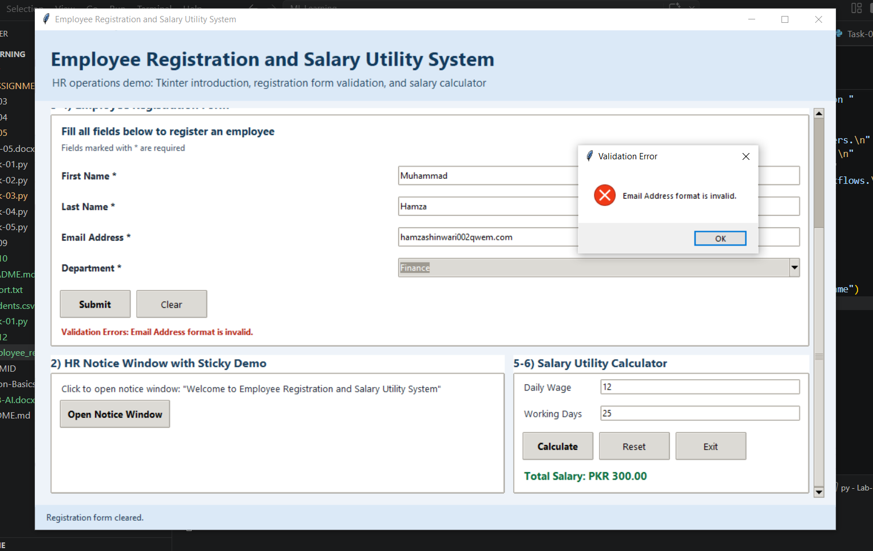
Email is not valid they show clear errors.

{THE END}

